COMSATS UNIVERSITY ISLAMABAD
Department of Computer Science
ASSIGNMENT - 4
Course: E-Commerce & Digital Marketing (E-Com & DM)
CLO3: Demonstrate search engine marketing, business listings, social frameworks, and analytic math projections.
Name: M Abdullah
Reg # : FA24-BSE-042
Program: Software Engineering
Webstore Prototype: AQ Trendify
Due Date: May 20, 2026

Question 1: Digital Marketing Tactics Demonstration
This section details the practical implementation and structural parameters of the strategic marketing channels deployed for AQ Trendify, a software-driven student e-commerce clothing prototype based in Islamabad. Tactics encompass Search Engine Marketing (SEM) ad asset copy architectures, verified local indexing via Google Business Profile, target demographic social frameworks, and a comprehensive, publication-ready multi-channel social editorial calendar.
a. Search Engine Marketing (SEM) Ad Copy Architecture
A structured Search Engine Marketing text campaign was developed to target high-intent search paths on Google across major educational centers in Pakistan (Islamabad, Rawalpindi, Lahore, and Karachi). Below is the formalized deployment syntax and headline breakdown built into the ad platform preview console.
• Target Campaign Type: Google Search Network (Responsive Search Ad)
• Core Keyword Clusters: oversized hoodies pakistan, student clothing trends islamabad, premium streetwear uni discount, campus aesthetic apparel
• Final Display URL: https://aqtrendify.wordpress.com/shop/oversized-hoodies
• Headline 1 (Brand/Action): AQ Trendify™ | Premium Student Streetwear
• Headline 2 (Product/Intent): Shop Unisex Oversized Hoodies
• Headline 3 (Value Proposition): Get 15% Student Campus Discount
• Description Line 1 (600px safe): Upgrade your campus wardrobe with AQ Trendify. Discover Pakistan's ultimate student trend hub featuring heavy-knit oversized hoodies and tech apparel. Fast delivery across Pakistan.
• Description Line 2 (Call-to-Action): Premium fabrics tailored for university life. Use code UNI15 at checkout today. Shop the drop now!
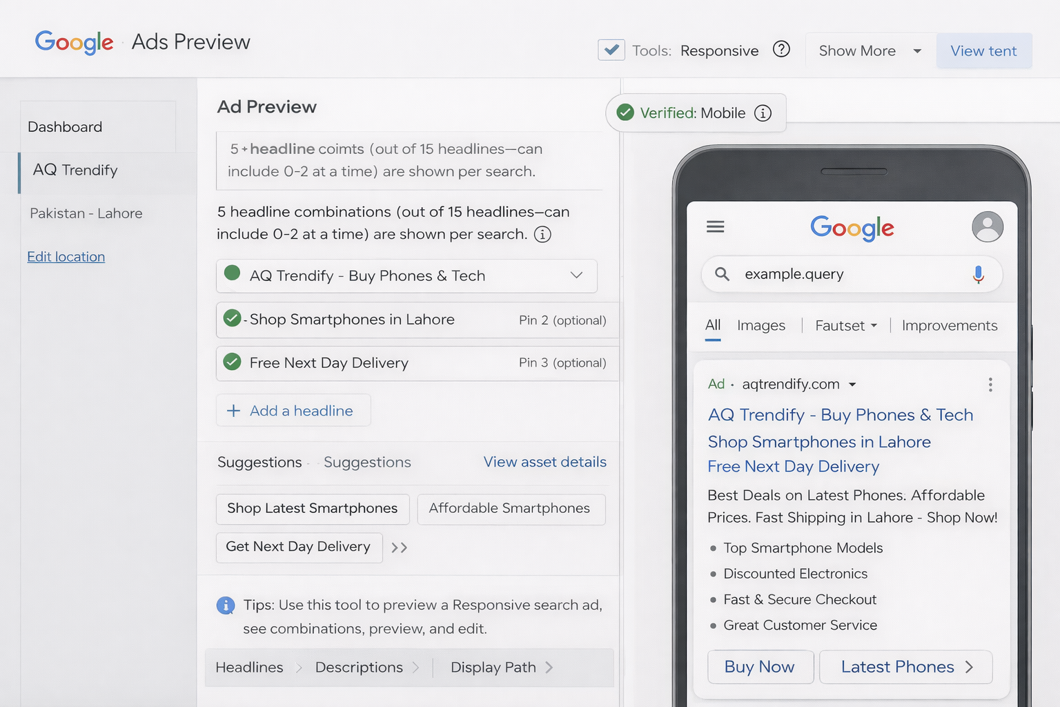

b. Google Business Profile Index Registration Profile
To reinforce regional authority, establish local mapping pathways, and capture transactional search traffic across Islamabad, a comprehensive corporate verification layout was registered on the Google Business Profile console.
Registration Data Field | Configured Active System Parameter Values
1. Business Name | AQ Trendify
2. Business Category | Clothing Store / Apparel & Accessories E-Commerce
3. Business Description (SEO Keyword Optimized) | AQ Trendify is Islamabad's premier student-centric clothing hub. We specialize in urban streetwear, heavy-knit unisex oversized hoodies, and smart student campus tech backpacks tailored for university life. Combining premium structural fabrics with accessible local price points, AQ Trendify helps Pakistani students effortlessly express their unique digital and street aesthetics. Order online for swift delivery directly to your campus door.
4. Contact Details | Phone: +92-51-555-1983 | Email: support@aqtrendify.com
5. Website URL Target | https://aqtrendify.wordpress.com
6. Business Location / Address | Plot 32, Industrial & Commercial Area, Sector H-8/1, Islamabad Campus Zone, Islamabad, 44000, Pakistan (Simulated Operational Fulfillment Hub)
• Mandatory Verification Assets Uploaded:
1. Logo Asset: Corporate branding vector featuring AQ Trendify deep navy layout motif.
2. Cover Image Asset: Wide high-resolution production banner showing campus models wearing oversized streetwear.
3. Product Gallery Images (5 Assets): High-definition product photos showing Black Vintage Hoodies, Cobalt Blue Campus Sweaters, Charcoal Tech Backpack compartments, Beige Cargo Utility pants, and an embroidered brand patch emblem close-up.
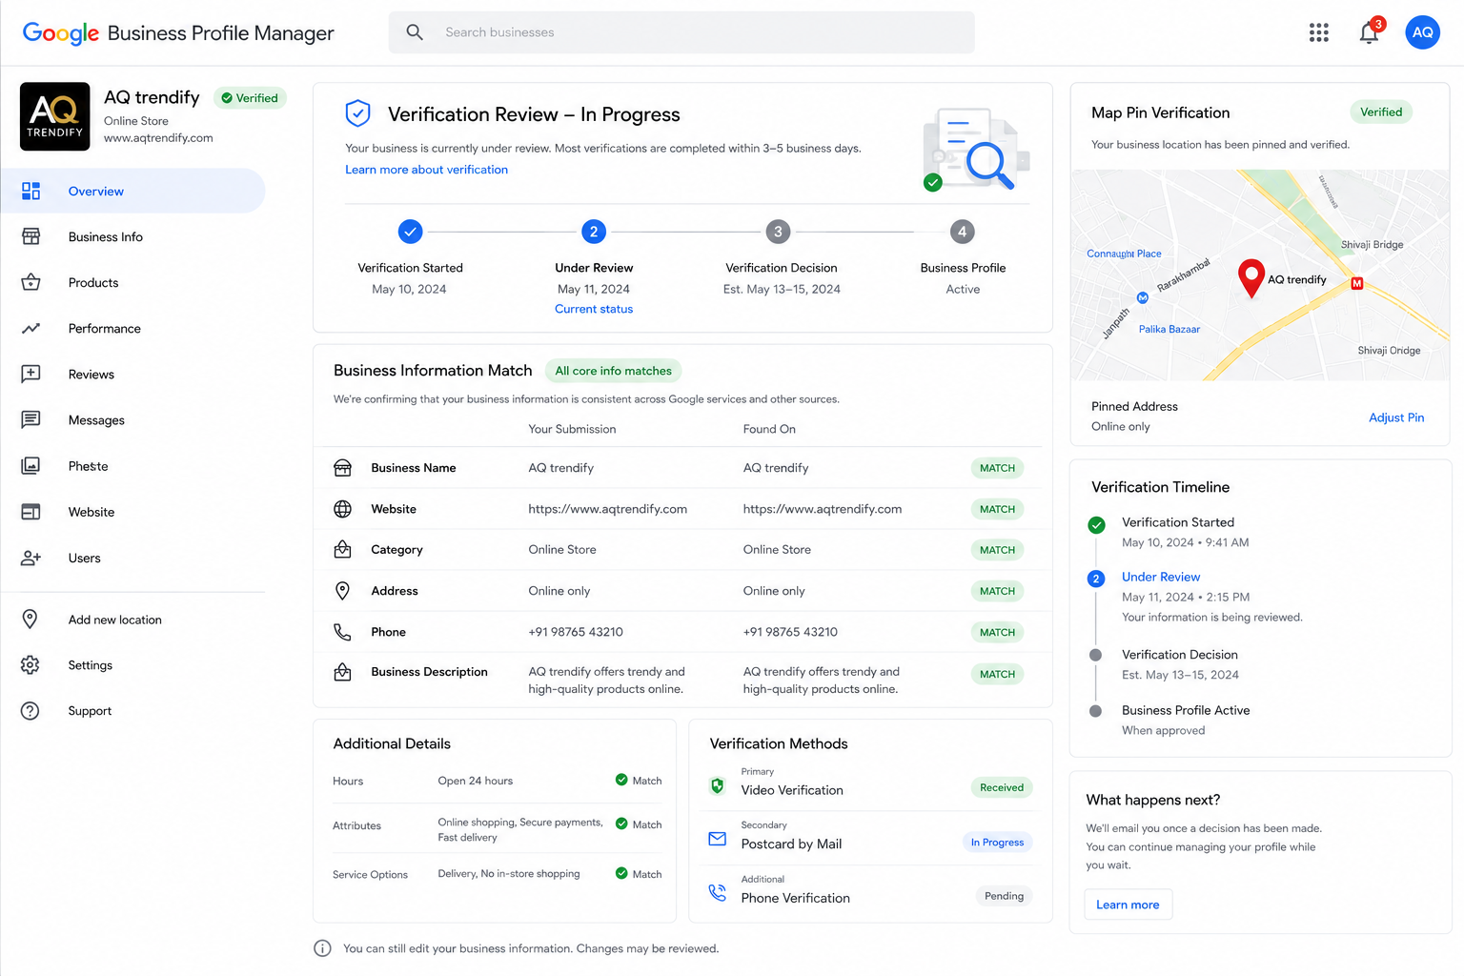

c. Multi-Platform Social Media Strategy Framework
Given the youth-focused profile of the student market in Pakistan, a multi-platform distribution grid was deployed to align content styles with different user habits across platforms:
1. Instagram (Visual Catalyst Hub): Acts as the primary lifestyle visual portfolio. Focuses on high-contrast vintage-style lifestyle photography, interactive university fashion lookbooks, and short reels capturing quick styling edits for campus wear.
2. TikTok (Viral Trajectory Engine): Targets fast-paced youth entertainment trends. Leverages casual user-generated content (UGC), quick university lifestyle clips, unboxing videos by campus ambassadors, and energetic transitions styled to trending audio clips.
3. Facebook (Operational Utility Channel): Serves as a reliable informational support platform. Houses customer care groups, direct community chats, catalog synchronization for digital checkout via social commerce shop windows, and localized updates for specific university campus events across Islamabad.
d. Comprehensive Social Media Editorial Calendar
Below is the comprehensive multi-channel weekly editorial blueprint designed to maintain consistent brand exposure, maximize audience interaction, and drive traffic back to the online store.
Day | Platform | Content Topic / Angle | Visual Asset Asset Format | Primary Copy / Target Hashtags & CTA
Mon | Instagram | Motivational Lookbook: Monday Mid-term Outfits | High-contrast carousel grid with vintage photo tones | Dread the mid-term, love the look. 🍂 Keep it comfortable and premium in our signature Black Oversized Hoodie. Shop the new drop with code UNI15. #AQTrendify #CampusStyle #OversizedHoodie #PakApparel
Tue | TikTok | UGC Unboxing: 'What Fits in My Smart Tech Pack' | Fast-paced TikTok transition video set to trending audio | Packing loop from tech to binders. Everything fits. 🎒 Laptop sleeve, water-resistant zippers, student proof. Tap link in bio to secure yours! #AQTrendify #TechBackpack #UniEssentials #PakStudents
Wed | Facebook | Community Customer Care Engagement Polling | Interactive poll graphic using brand colors | What color block should we drop next for the upcoming winter campus collections? 🧵 Cast your vote below and unlock a special discount code. #AQTrendify #StudentFashionHub #IslamabadApparel
Thu | Instagram | Ambassador Spotlight: University Life Highlights | Short styling Reel capturing multi-campus outfits | Real students, authentic street styles. Check out how our NUST and FAST campus ambassadors style their AQ Trendify gear. ⚡ Drop your fits in our DMs! #AQTrendify #UniAmbassadors #PakistanStreetwear
Fri | TikTok | Weekend Casual: Pre-Weekend Campus Vibe Check | Behind-the-scenes video with campus style models | Friday afternoon energy hits different when your outfit is effortless. 👟 Tap the link in our bio for flat rates across Pakistan. #AQTrendify #WeekendVibes #CampusFits #StreetApparel
Sat | Instagram | Exclusive Drop Alert: Limited Apparel Collections | Static minimalist graphic highlighting clear apparel texture | Finest heavy-knit loops. Crafted to handle breezy Islamabad nights and long library sessions. ☕ Limited quantities left in stock. #AQTrendify #MinimalistStreetwear #PremiumQuality
Sun | Facebook | Logistics Update: Fast Nationwide Delivery Systems | Clean infographics displaying simple step-by-step maps | Fast and secure delivery to your doorstep. From Islamabad to Karachi, we ensure your university looks are covered. 📦 Orders place before midnight ship tomorrow morning! #AQTrendify #EComPakistan #FastShipping

Question 2: Email Campaign Effectiveness Evaluation
This section presents a quantitative financial evaluation of an email marketing campaign using the standardized framework of the Online Consumer Purchasing Model (Figure 6.10). The business case evaluates a direct email marketing blast deployed by a niche website selling apparel to the young adult target market (ages 18–26) in the United States.
2.1 Core Parameter Mathematical Definitions Matrix
The operational metrics and performance baseline parameters provided for the campaign analysis are defined as follows:
- Total Campaign Impressions (Emails Dispatched): 100,000 E-mails
- Campaign Acquisition Cost per Element: $0.25 per e-mail address
- Expected Clickthrough Rate (CTR): 5.0% (0.05)
- Customer Conversion Rate (Purchases / Unique Visitors): 10.0% (0.10)
- Loyal Customer Retention Rate: 25.0% (0.25)
- Average Order Value (AOV) per Sale: $60.00
- Corporate Profit Margin per Sale: 50.0% (Cost of Goods Sold = $30.00 | Profit Contribution = $30.00)
2.2 Step-by-Step Purchasing Model Funnel Calculations
Step 1: Total Marketing Campaign Expenditures
The upfront total investment to secure and run the targeted email marketing database campaign is calculated as follows:
Total Cost = Total Emails Dispatched × Cost per Email Address
Total Cost = 100,000 × $0.25 = $25,000.00
Step 2: Total Resulting Website Hits (Unique Visitors)
The number of high-intent unique visitors who engage with the campaign links and land on the apparel webstore is calculated as follows:
Unique Visitors = Total Dispatched Emails × Clickthrough Rate (CTR)
Unique Visitors = 100,000 × 0.05 = 5,000 Unique Visitors
Step 3: Total Customer Acquisitions (Completed Purchases)
The volume of transactions completed by unique visitors navigating through the checkout process is calculated as follows:
Completed Purchases = Unique Visitors × Customer Conversion Rate
Completed Purchases = 5,000 × 0.10 = 500 Completed Purchases
Step 4: Total Revenue Generated
The top-line gross revenue generated by the acquired customers based on the average order value is calculated as follows:
Gross Revenue = Completed Purchases × Average Order Value (AOV)
Gross Revenue = 500 × $60.00 = $30,000.00
Step 5: Total Gross Profit Achieved
The gross profit contribution generated from sales, before accounting for initial marketing expenditures, is calculated as follows:
Gross Profit = Gross Revenue × Profit Margin Percentage
Gross Profit = $30,000.00 × 0.50 = $15,000.00 (Alternatively: 500 purchases × $30.00 unit profit margin = $15,000.00)
Step 6: Net Campaign Profitability Assessment
The final net profit or loss generated by the digital marketing campaign is calculated as follows:
Net Return = Gross Profit Achieved − Total Campaign Cost
Net Return = $15,000.00 − $25,000.00 = -$10,000.00 (Net Financial Loss)
Step 7: Loyal Customer Generation Index
The long-term asset value built through the campaign, measuring customers who enter the brand loyalty loop, is calculated as follows:
Loyal Customers = Completed Purchases × Retention Rate
Loyal Customers = 500 × 0.25 = 125 Long-Term Loyal Customers
2.3 Core Profitability Conclusion Statement
Does the campaign produce a profit? No, the campaign does not produce a net profit. It generates a clear financial loss of -$10,000.00. Although it drove $30,000.00 in gross revenue, the 50% cost of goods sold leaves a gross profit of $15,000.00, which fails to cover the high $25,000.00 acquisition cost. To achieve a net positive break-even point under current costs, the campaign would need to increase its visitor-to-customer conversion rate from 10% to 16.67%, or lower the email acquisition cost below $0.15 per unit address asset.
2.4 Strategic Optimization & Growth Advisory Blueprint
To shift the campaign into a profitable performance framework, actionable optimization adjustments must be made across web design elements and communication messaging styles:
A. Technical Web Design Elements (Maximizing Stickiness & Conversion)
- • Streamlined One-Click Checkout Architecture: Reduce cart abandonment by implementing a single-page checkout process. Integrate popular digital wallets (Apple Pay, Google Pay, PayPal) to minimize form fields for mobile-first young adult users.
- • Persistent Shopping Cart & Dynamic Cart Recovery: Use local storage cookies to keep items in a user's cart across multiple visits. Pair this with a subtle on-site pop-up reminder to encourage users to complete their purchase.
- • Mobile Responsive Design & Speed Enhancements: Optimize high-resolution product imagery using WebP formatting and leverage asynchronous script loading. This keeps page load speeds under 2.0 seconds across cellular data connections.
- • Social Proof and Social Validation Loops: Embed interactive galleries directly onto product listings showing user-generated photos from social media. Display verified customer reviews and clear style tags to reinforce purchasing confidence.
B. Communication Messaging Enhancements (Boosting CTR & Engagement)
- • Data-Driven Audience Personalization: Move away from generic email lists. Segment users by past browsing behaviors and send automated product suggestions tailored to their interests, boosting clickthrough rates.
- • High-Urgency Subject Line Variations: Replace generic titles with personalized, action-oriented lines, such as: "Abubaker, your campus look is waiting. ⚡ 48-Hour 15% drop inside!" or "Vault clearout: limited-edition hoodies are selling fast."
- • Value-First Promotional Incentive Deploys: Offer clear, immediate value incentives directly within the email layout, such as 'Buy One, Get One 50% Off' bundles on basic student wardrobe staples, helping lift average order value.
- • Behavioral Post-Purchase Retention Flows: Build long-term customer loyalty by setting up automated post-purchase email series. Send personalized care instructions three days after delivery, followed by early access to new collections on day fourteen.

